For my final 3D scene, I plan to recreate a simple desk setup. I chose this scene because it contains several objects that I can recreate using basic 3D shapes, while still giving me enough variety to practice my modeling skills such as transformations and scale. A desk scene is also aa realistic scene because it contains objects that have clear geometric forms, such as boxes and cylinders. I believe this will make the project achievable while still allowing some creative freedom.
The main objects I plan to replicate are a desk surface, a computer monitor, a keyboard, a mouse, and a coffee mug. The desk surface will be the foundation for the scene and will be created using a plane. This will ground the remaining objects and provide a surface for arranging everything. The computer monitor will be the main object in the scene and it can be built using a box for the screen and a cylinder for the stand with another box for the base.

The keyboard can be built using a rectangle. The mouse can be built using either a sphere or a cylinder depending on the look I’m trying to achieve. And finally for the coffee mug I will use a cylinder for the cup and a curved shape for the handle. The basic 3D shapes I plan to use include a plane, box, cylinder, sphere. The plane will be used for the desk or table surface. Boxes will be used for the monitor screen, monitor base, and the keyboard. Cylinders will be used for the monitor stand, and mug. I think this scene should satisfy all the requirements for the project because it will use 4 shapes and have 4 objects.

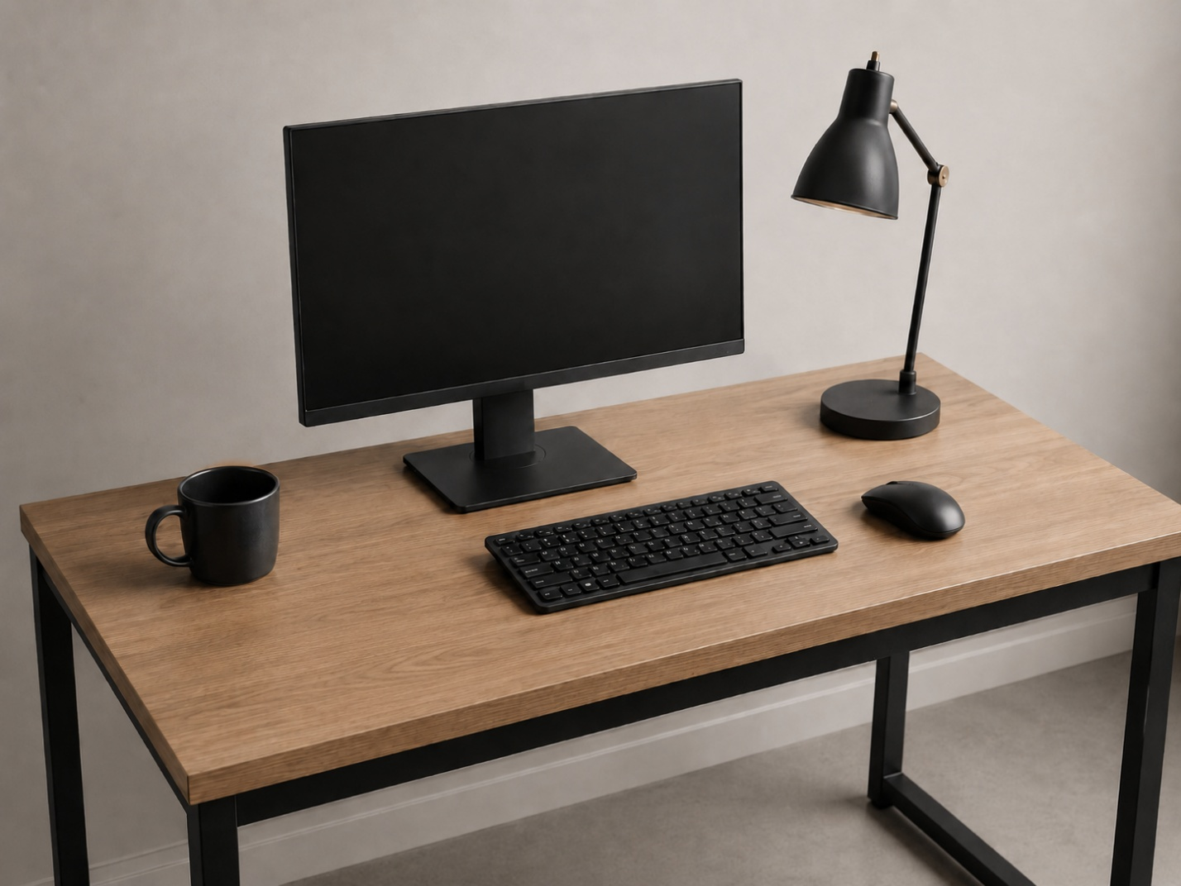
an AI-generated 2D reference image of a minimalist desk setup

Citation
OpenAI. (2026). AI-generated image of a minimalist modern desk setup with a monitor, keyboard, mouse, mug, and lamp [Image generated by ChatGPT]. ChatGPT.

